SHELL SCRIPTING

UNIX shell program interprets user commands which are directly entered by the user or which can be read from a file called the shell script or shell programming.

*Shell scrips are interpreted not compiled.

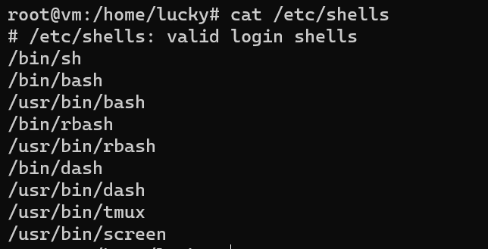

Bash stands for bourne again shell

Bash is an improved version of bourne shell(sh) and now-a-days it is standard GNU shell which is intuitive and flexible

To know where bash is located

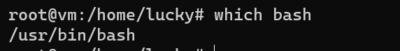

#! is called shebang or hashbang

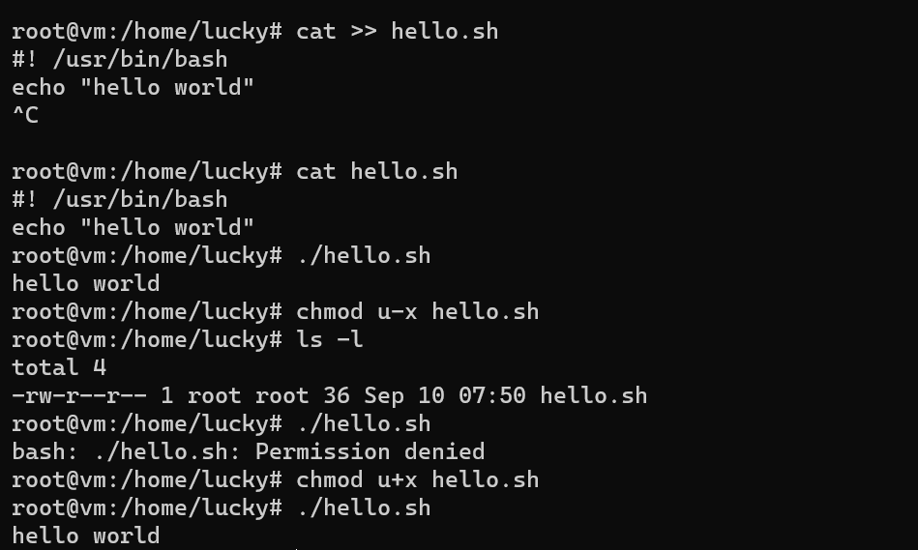

Commands are the lines of code which are not executed by our script helpful to know about our code.#

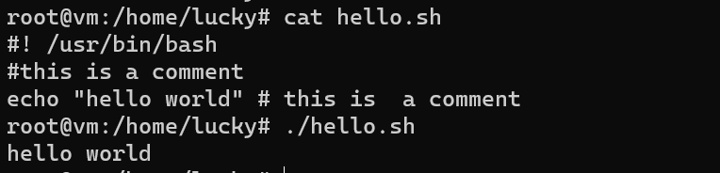

Variables are containers which store data inside it.

In the Unix system, there are 2 types of data

1. System variable

2. User-defined variable

System variables are created and maintained by linux or unix operating system.

These are the predefined variable which are defined by your operating system.

These are defined in capital cases.

User defined variables are the variables which are defined by user.

Generally these are in lowercase letters…but there is no rule to written in lowercase…we can write in uppercase as well

****System variable demo****

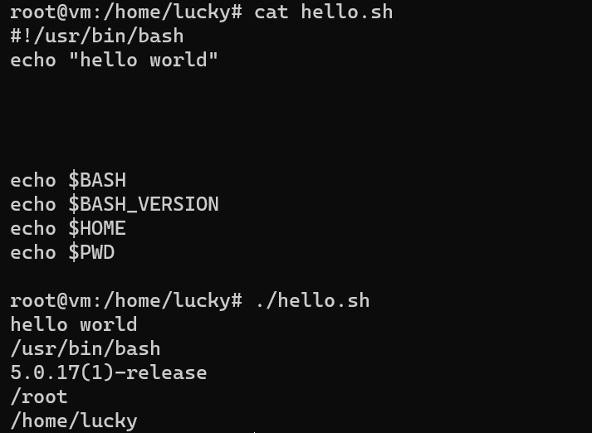

***User variable demo***

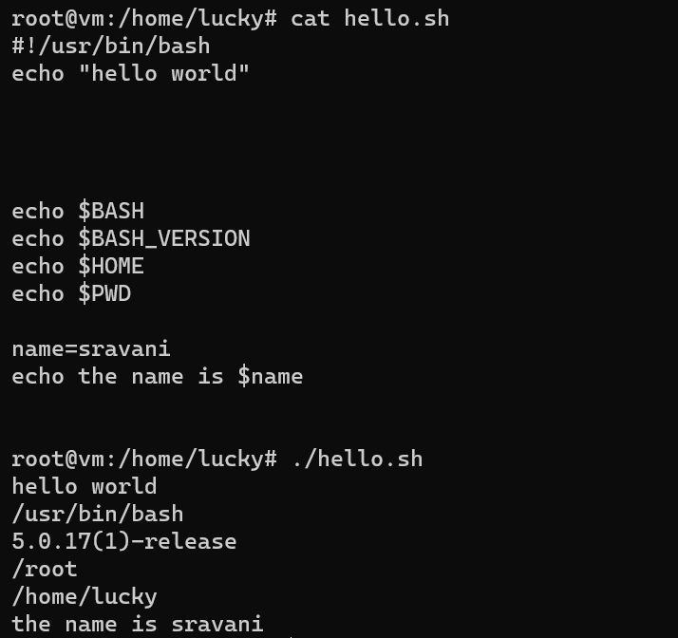

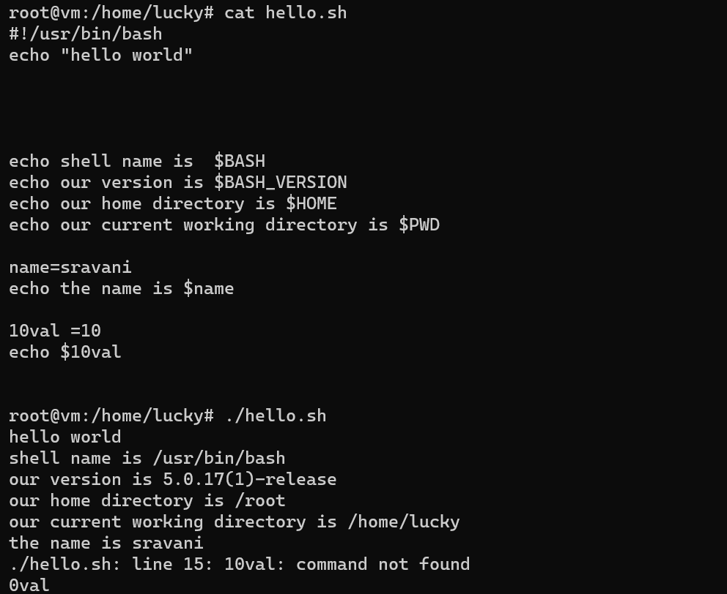

Here there is an error … Starting numerical cannot be taken as a variable name..

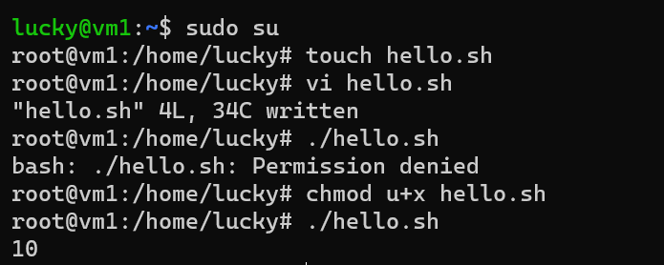

How to take input from the user????

Actually to take any input from the user ..use this command

Read variable name

Whatever value will be entered from the user ..that value will be stored in that variable name.

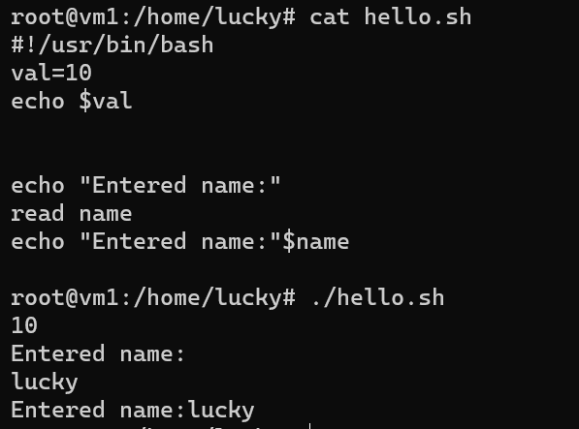

How to take multiple inputs from the user ??

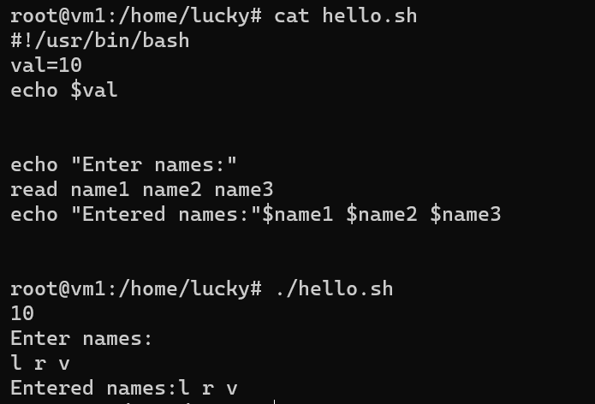

How to take user input in the same line??

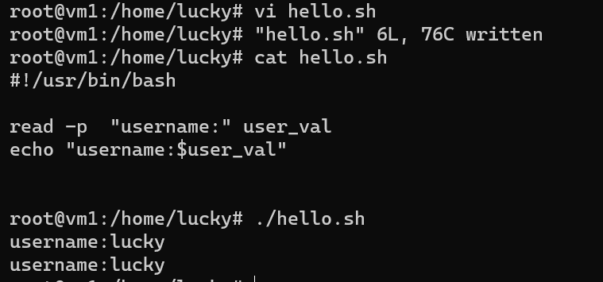

Ya…if user is entering some passwords we don’t want show that typing password to the people…what is user entering…

So we use the command -s

S for silent

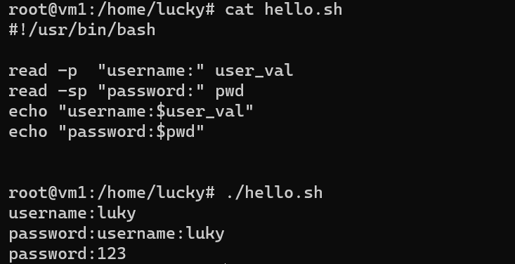

So the password which is entering by the user is not visible to the outside.

But we encounter an issue with this…username is also printing in same line..to resolve this…just add one echo under the password.

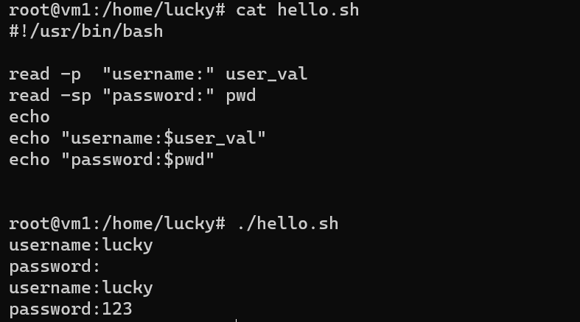

If you want to take a bunch of inputs from the user…we can use array

a is used to indicate array…let’s see what happens

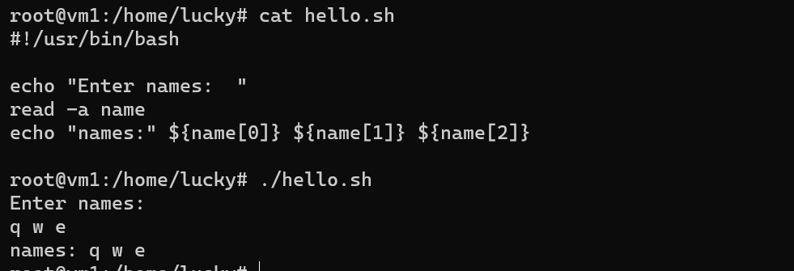

If you don’t take any variable for taking input ……..

An automatic system variable “REPLY” will be assigned ….

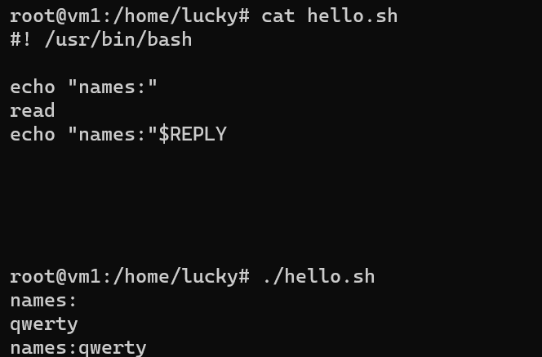

How to pass arguments to the bash script?

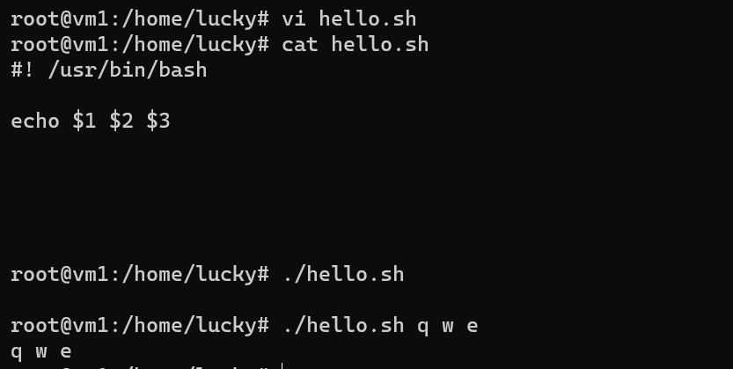

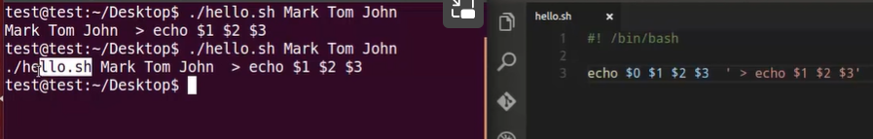

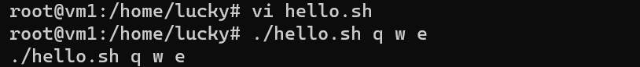

Another way of parsing into an array…

How to parse arguments into an array

$@ stores arguments into an array

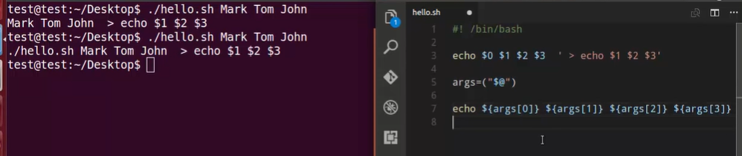

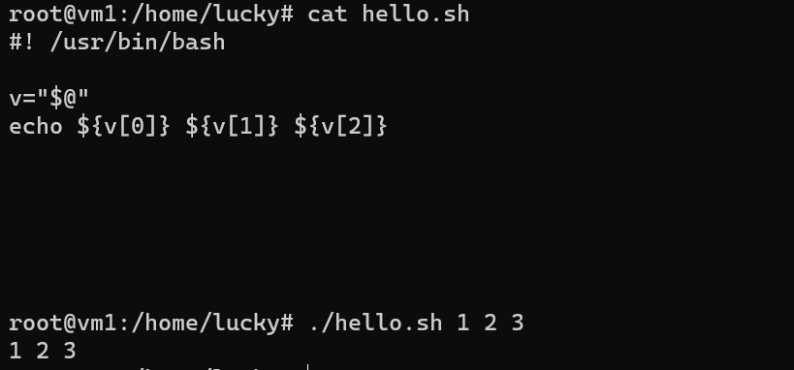

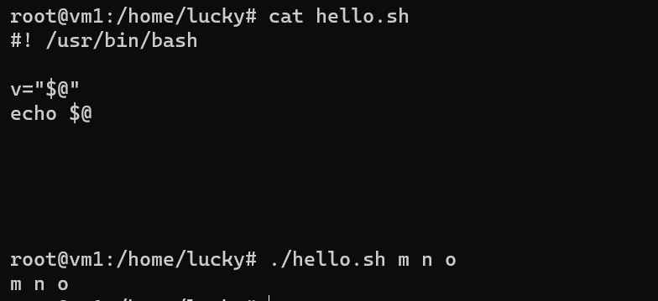

To print the no.of arguments passed to the shell…. $#

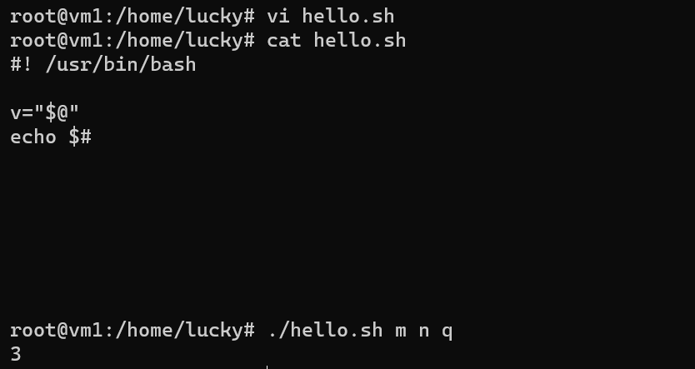

Conditional statements

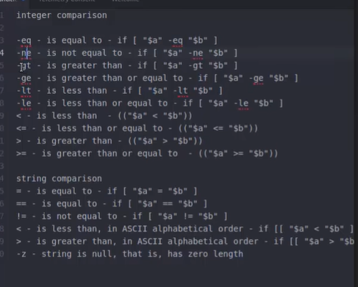

->Symbols are like(>,<,<=,>=) ….round brackets(()) are used …two sets of round brackets are used.

->For letters (eq,ne,ge,gt,lt,le)…square brackets[] are used….

-> for string comparison’s , [] square bracket is used..

*Basic syntax of if statement

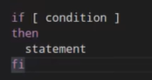

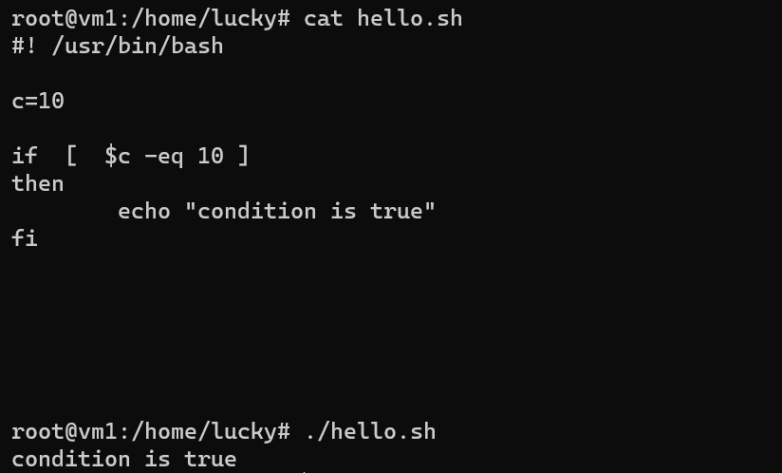

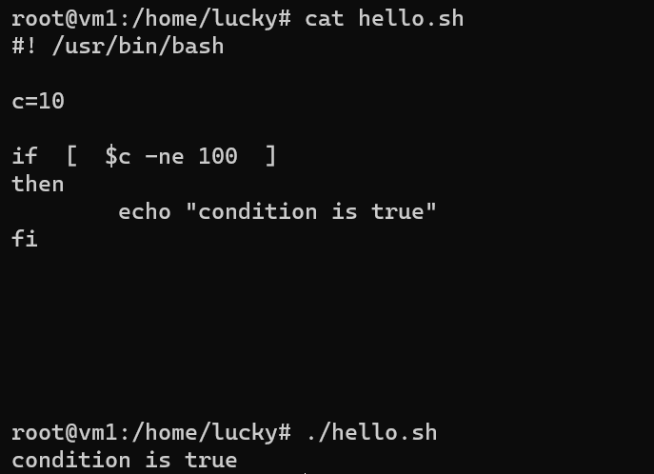

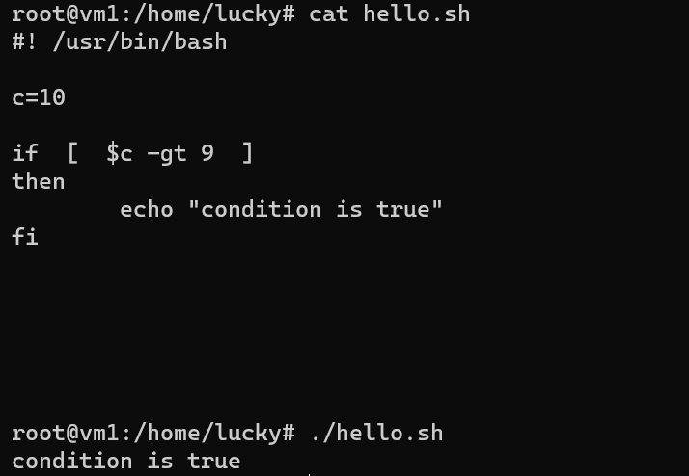

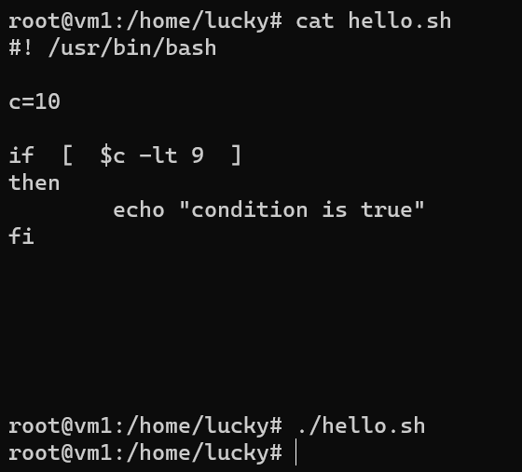

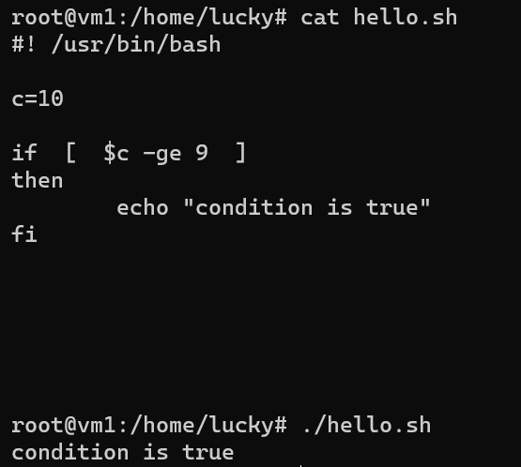

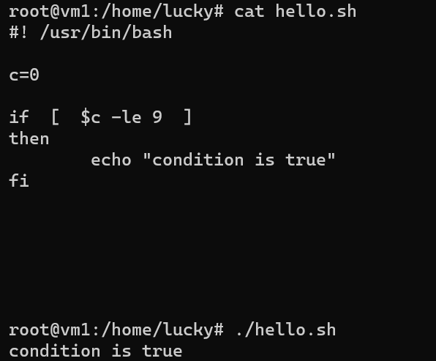

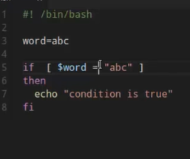

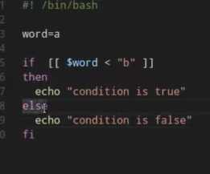

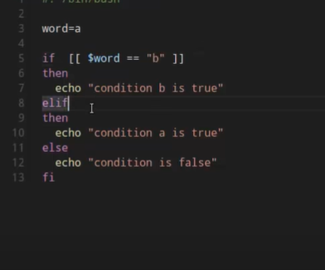

*****FILE TEST OPERATORS*****

If you want to place the cursor in the same line put \c ….it will print \c as it there… but along with \c we need to put -e…-e enables the functionality of \c …

To check whether the file exists or not a special flag is there

Command is -e filename

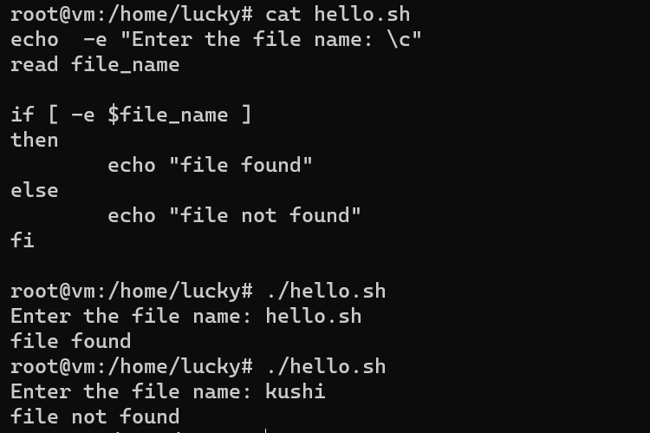

-e for file exists or not

-f is for file exists and file is a regular file or not

-d is whether that directories exists or not

For block special file we use flag -b

For character special file , we use flag -c

Flag which checks the file empty or not (-s)

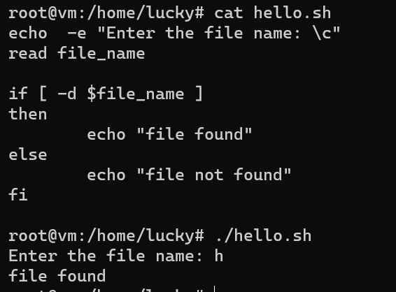

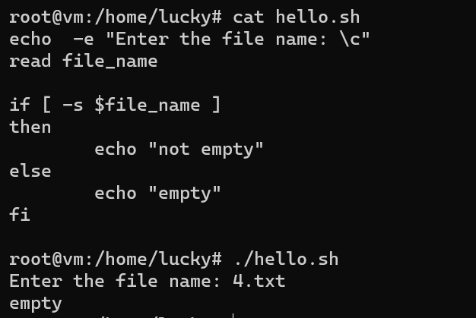

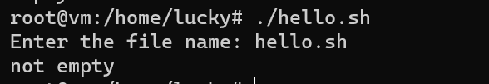

-w checks whether the file has write permission or not..

**How to append output to the end of text file**

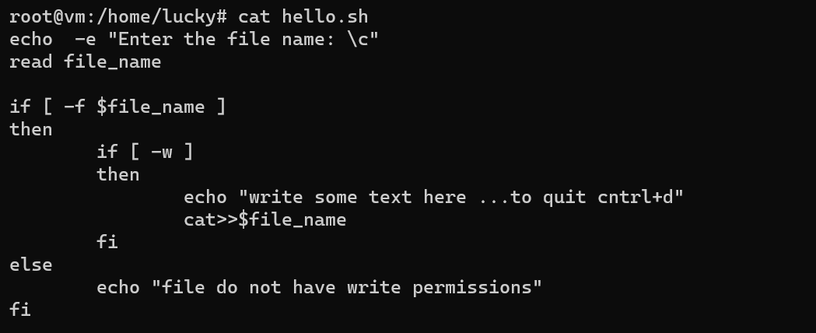

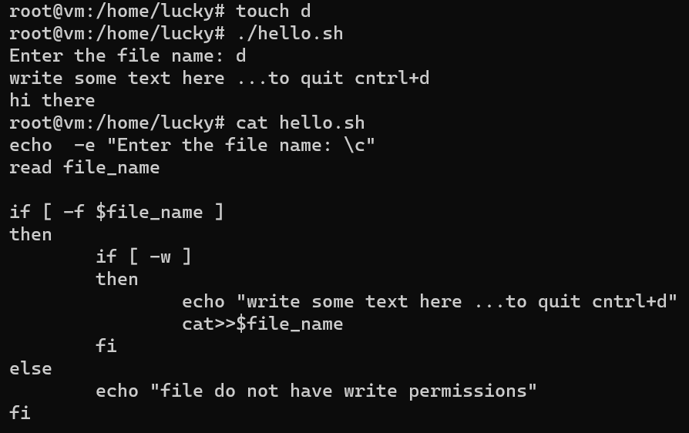

-a is used for and operator

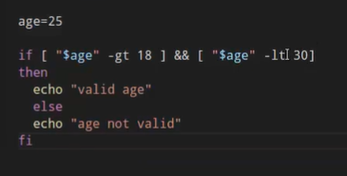

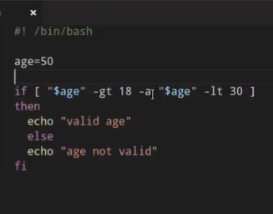

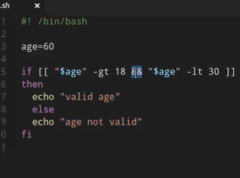

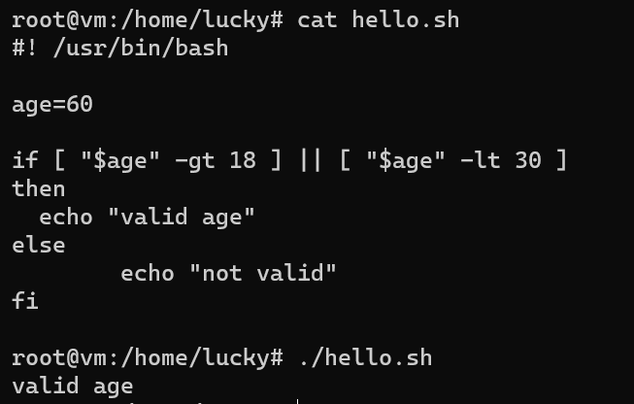

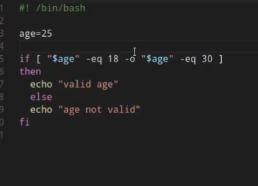

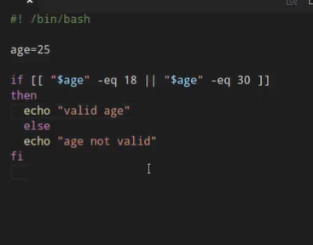

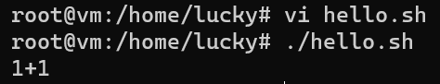

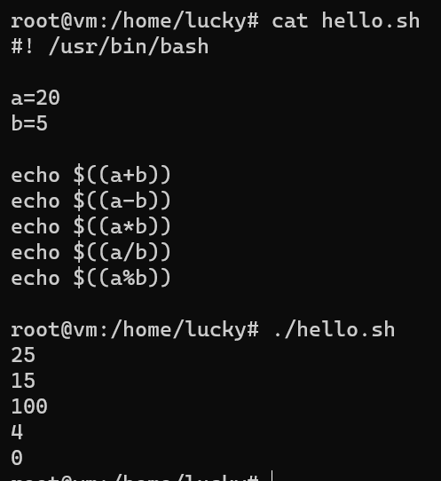

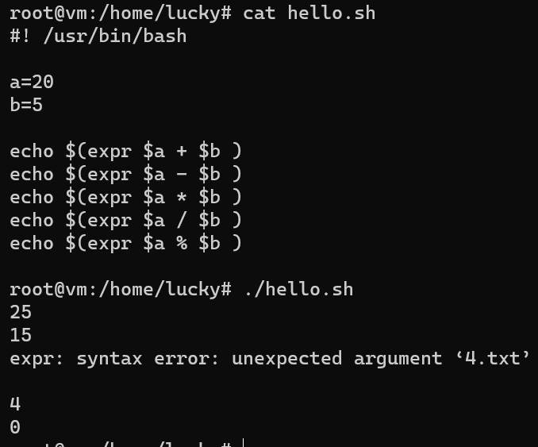

For expr method ..* symbol is not skipped we won’t get the expected output

But to resolve this error /* back slash in front of *

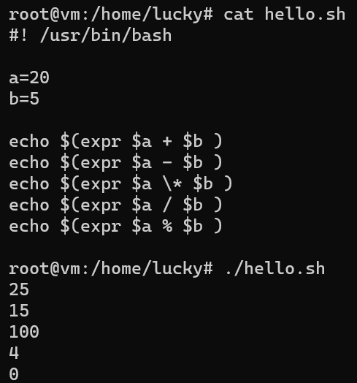

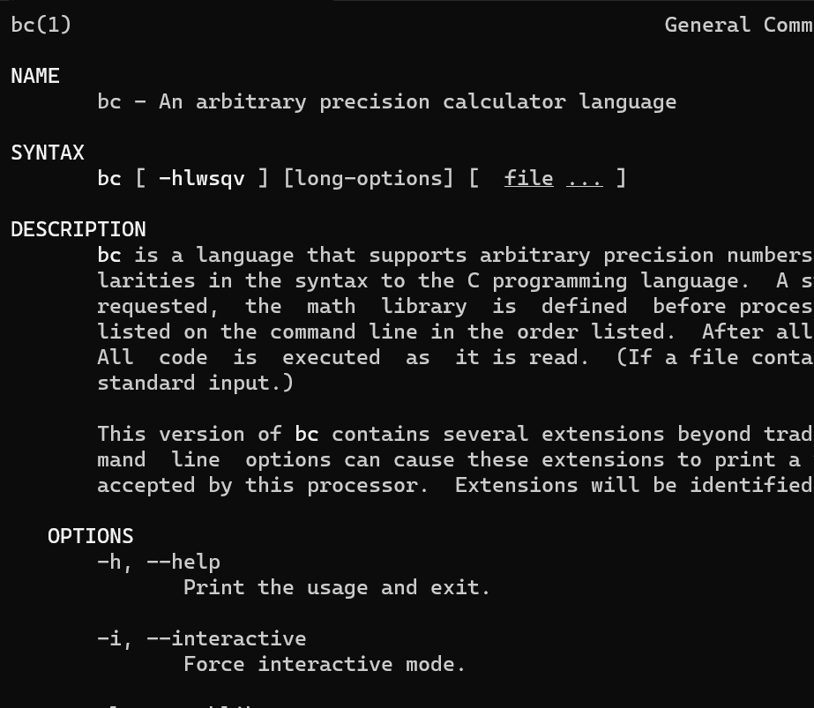



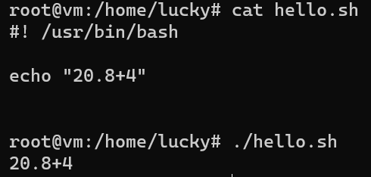

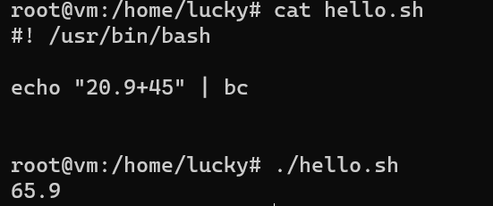

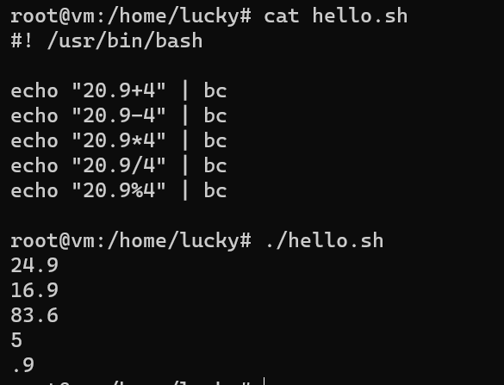

For division, it is not getting proper output, in terms of decimal points

Scale is used to fix 2 points after decimal

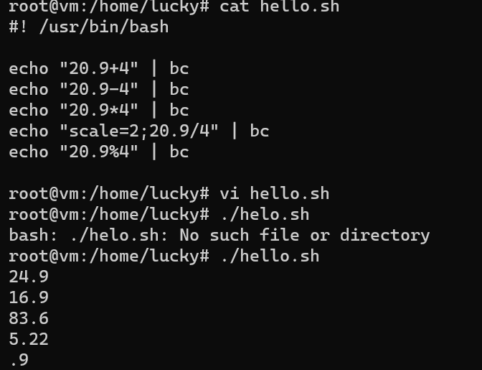

-l is used to call the math libraries like power,sqrt

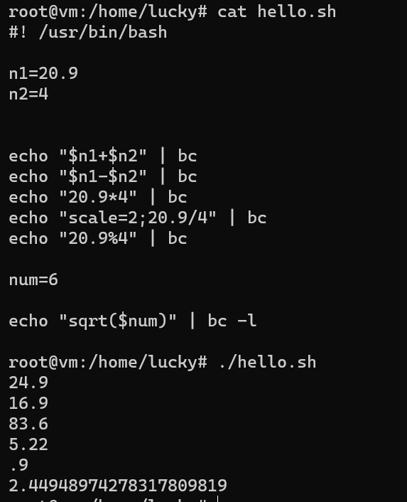

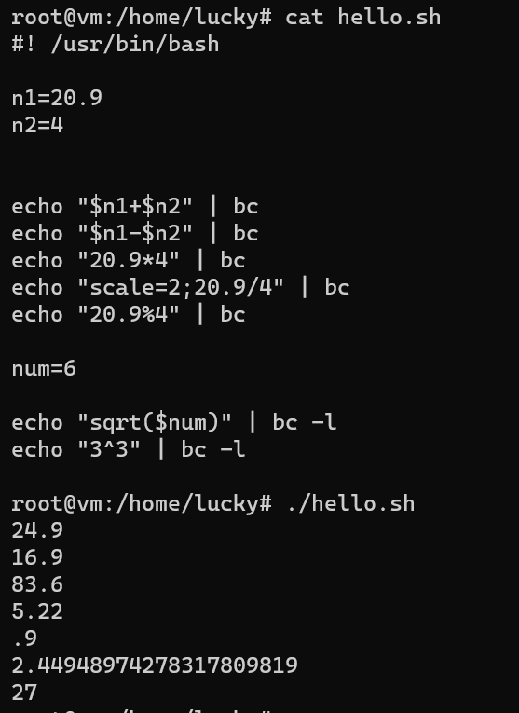

Case

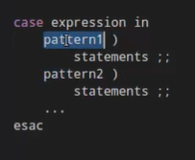

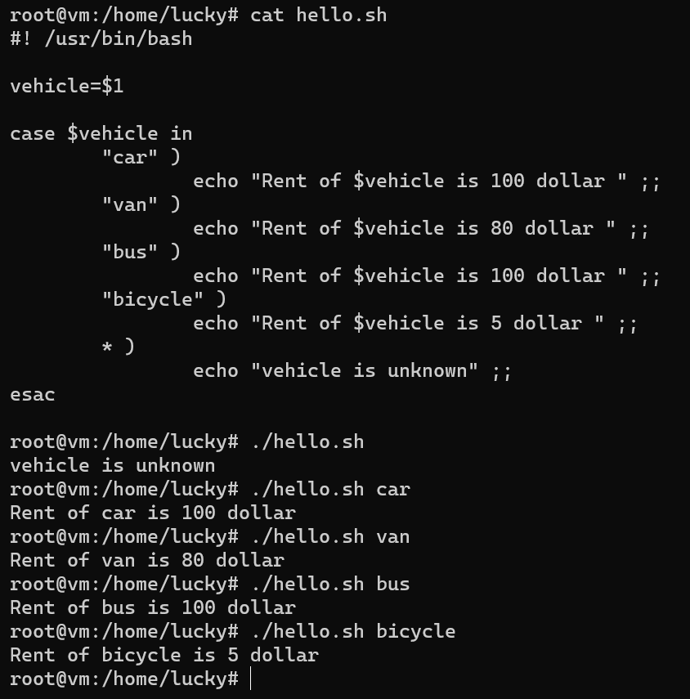

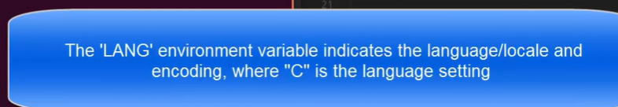

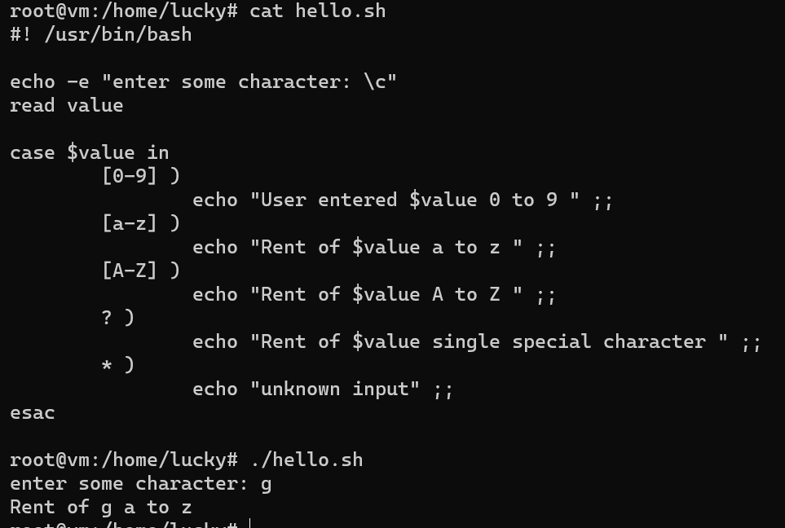

Array

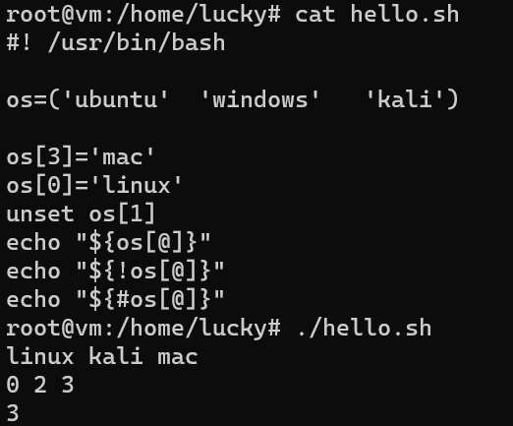

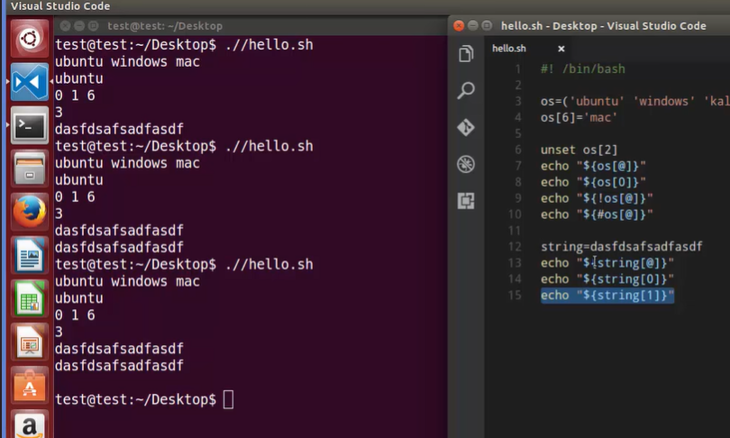

Length of the string is only one, if we assign string to array

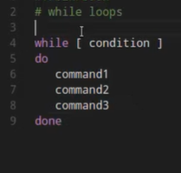

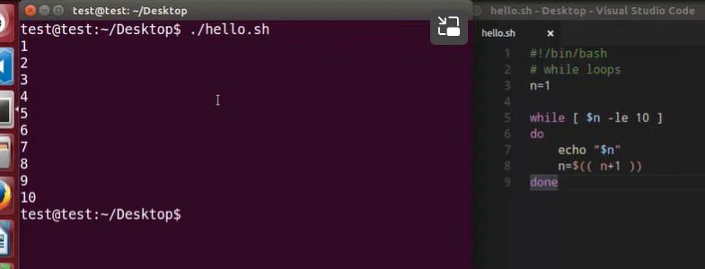

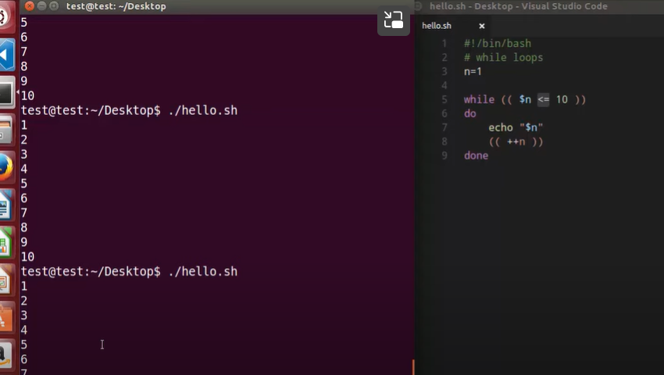

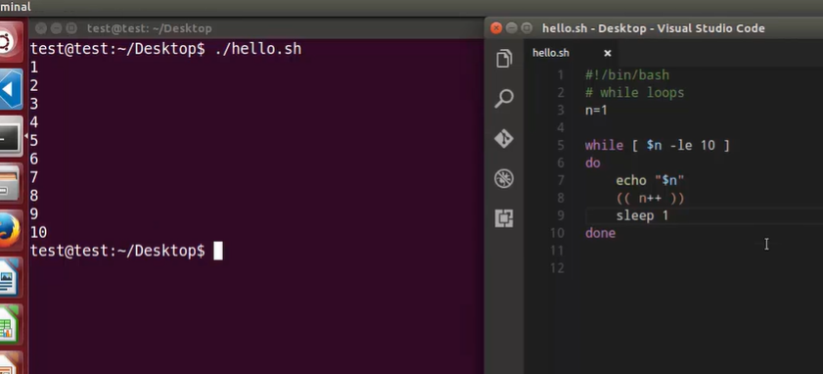

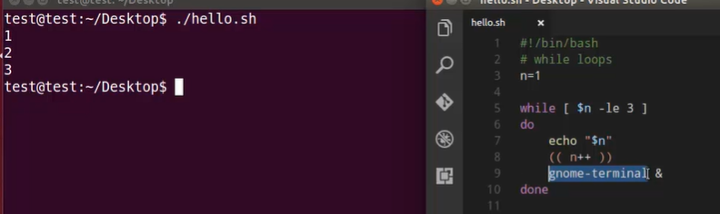

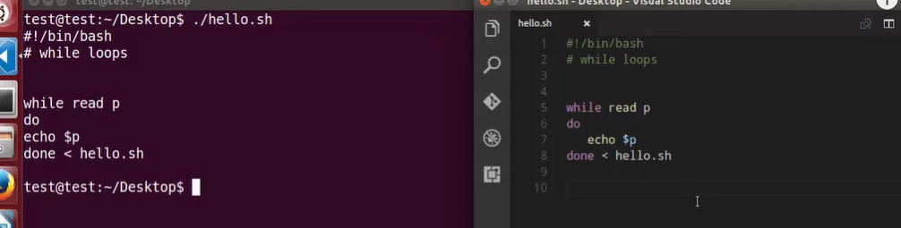

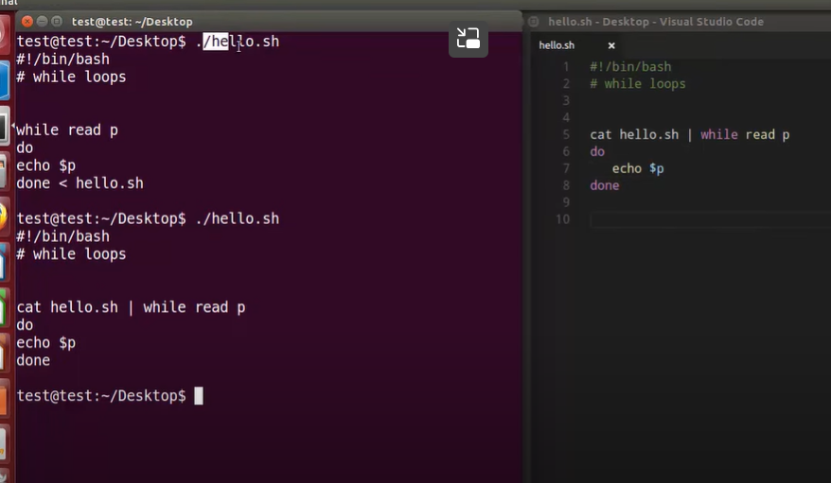

IFS stands for internal feel separator

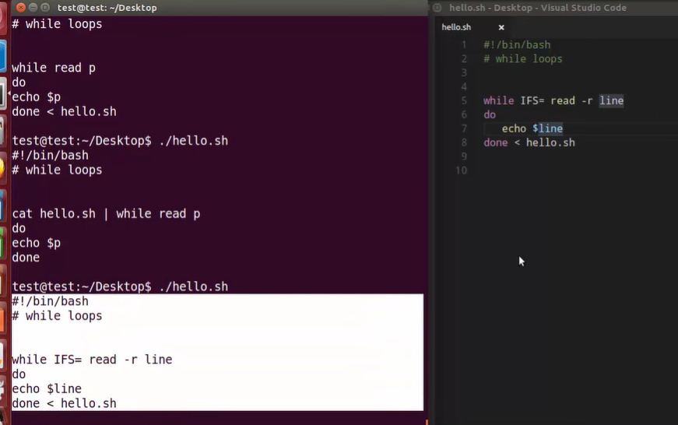  
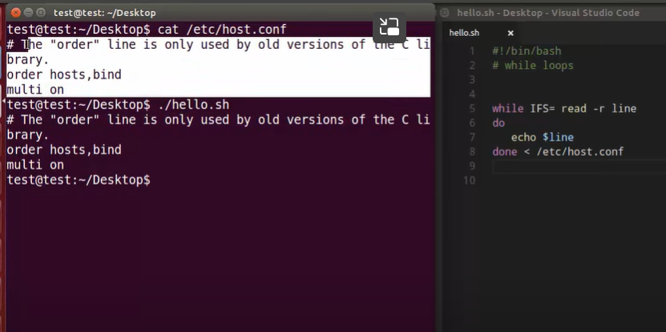

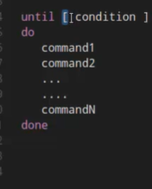

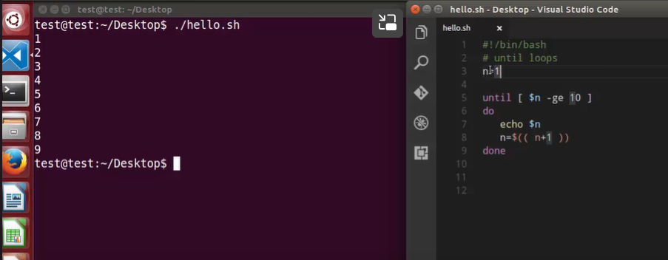

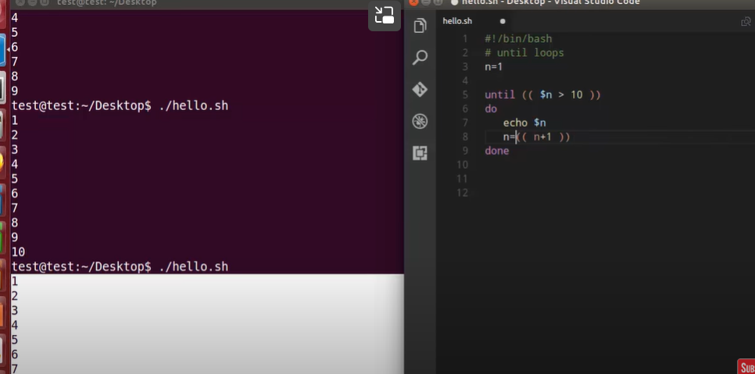

for Loops: Sometimes we want to run a command (or group of commands) over and over. This is called iteration, repetition, or looping. The most commonly used shell repetition structure is the for loop, which has the general form:

for variable in list

do

command(s)

done

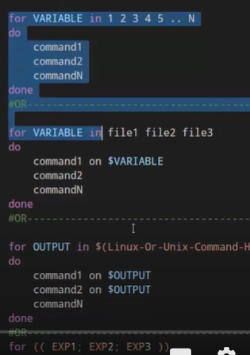

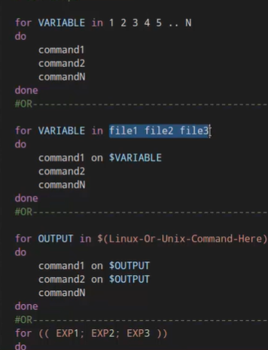

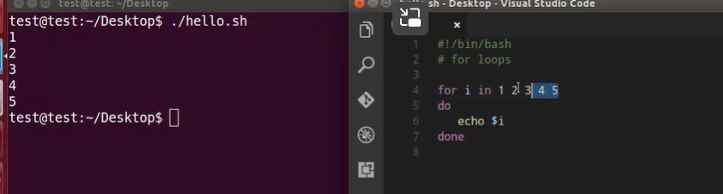

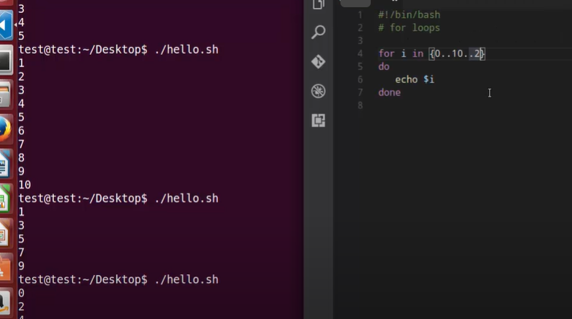



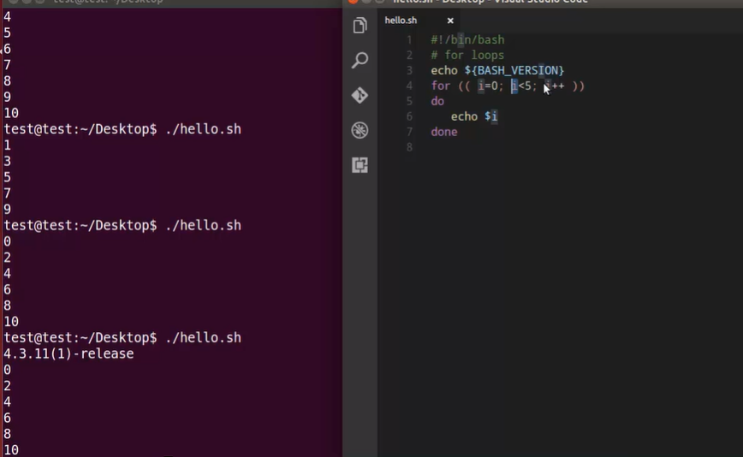

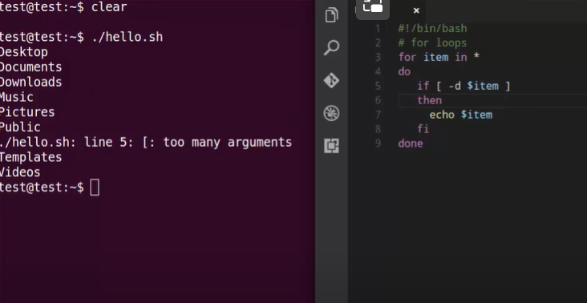

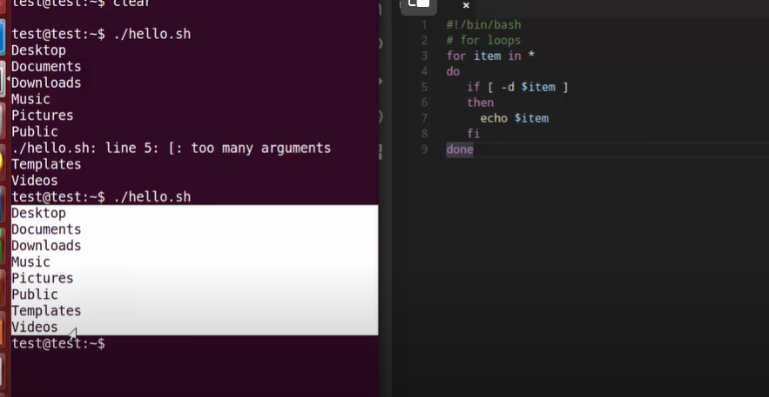

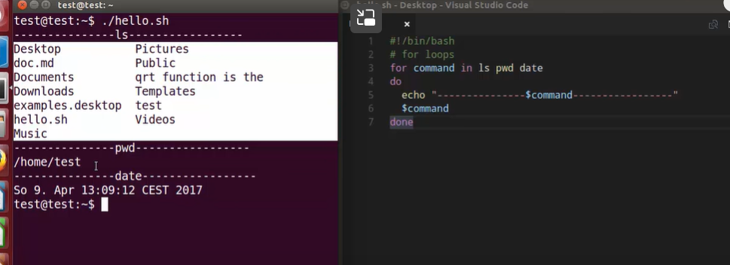

SELECT COMMAND Constructs simple menu from word list. It Allows user to enter a number instead of a word. So User enters sequence number corresponding to the word. -------------------------------------------- Syntax:

select WORD in LIST

do

RESPECTIVE-COMMANDS

done

--------------------------------------------

Loops until end of input, i.e. ^d (or ^c)

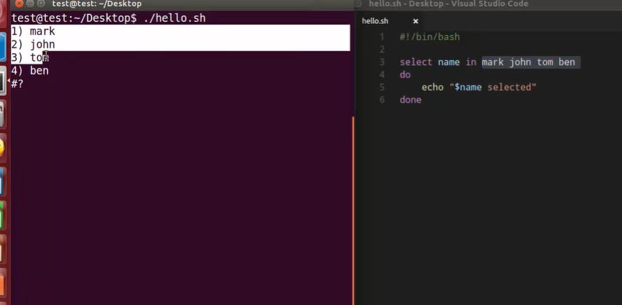

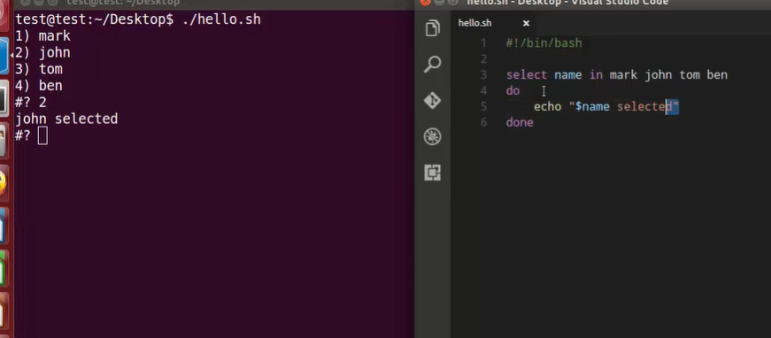

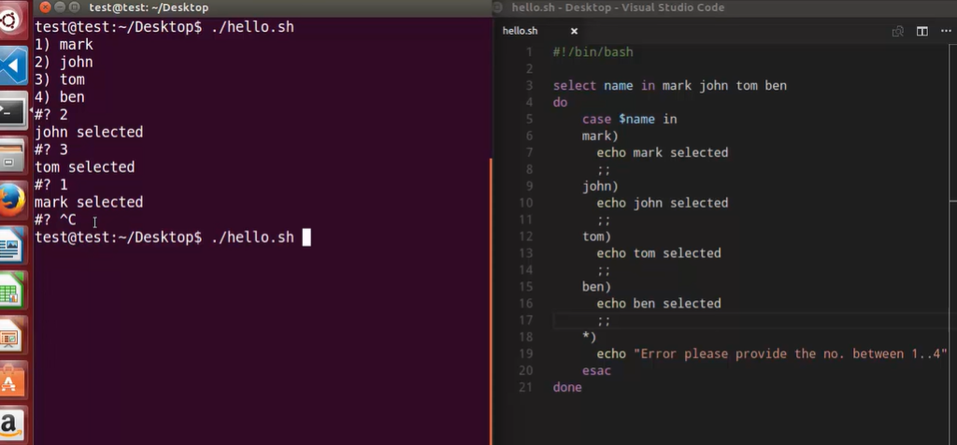

The break statement is used to exit the current loop before its normal ending. The continue statement resumes iteration of an enclosing for, while, until or select loop.

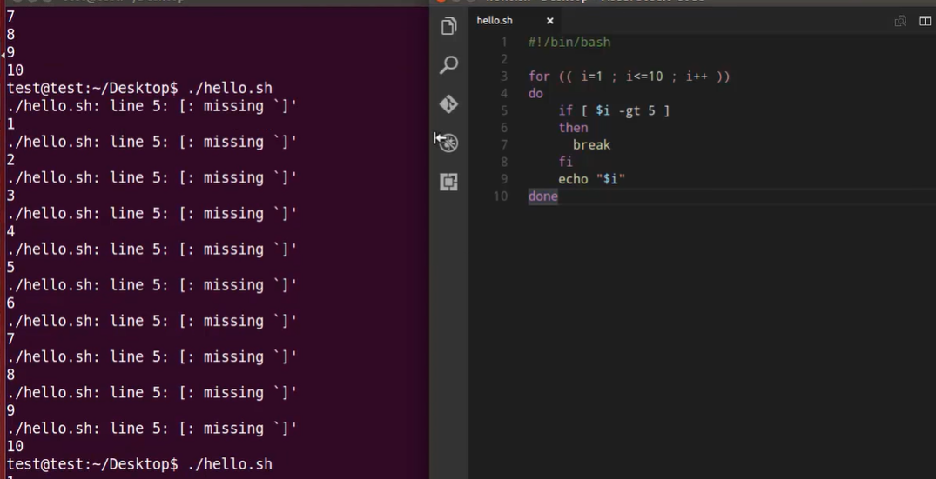

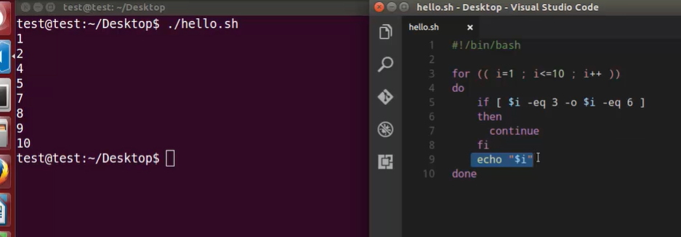

Functions : Functions make scripts easier to maintain. Basically it breaks up the program into smaller pieces. A function performs an action defined by you, and it can return a value if you wish.

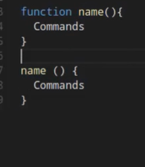

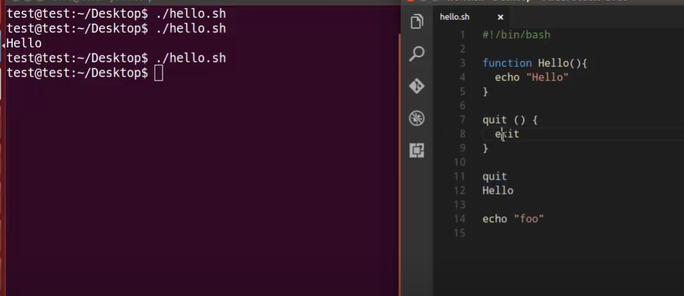

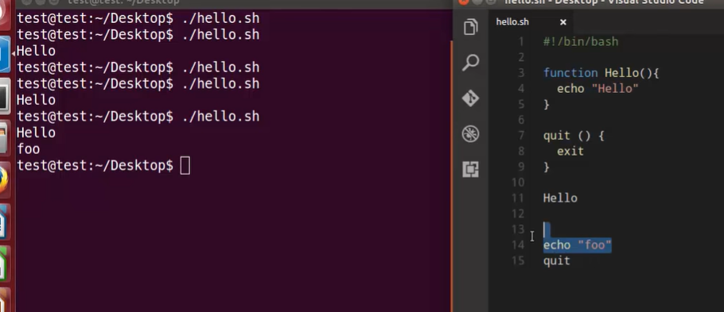

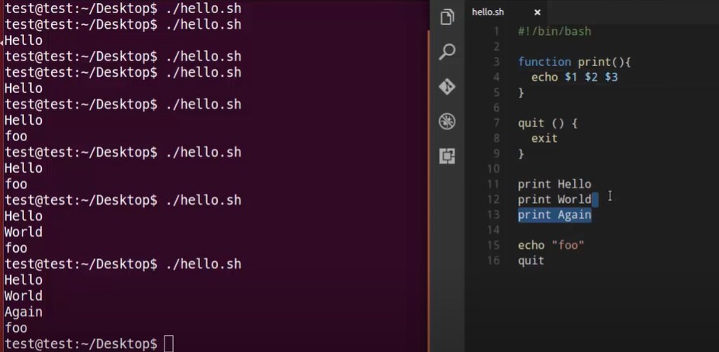

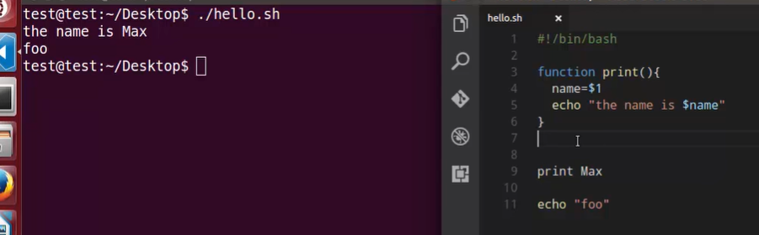

All variables are global in shell script

